**VILLAIN QUEST #1 METAL GEAR AFTAMATH**

@Villain Headquarters

FLYING CHICK: Listen up, punk. You think you're ready for your first job?

Choice

Yes {FLYING CHICK: (happy) Excellent! Now, you see these headquarters? These things don't come cheap. Radioactive wastelands require a LOT of upkeep. We gotta keep the business afloat. There's a certain gang that has a neat little pile of cash. You catching on? You break in, steal the money, and bring it back. If you get caught, we're not gonna come and haul you out. You're on your own with this. Show me what you go, punk.}

No {FLYING CHICK: (mad) Gotta say, I almost expected more from you. Offer's still on the table if you change your mind.}

**Expertly drawn map of what I imagine this place to look like:**

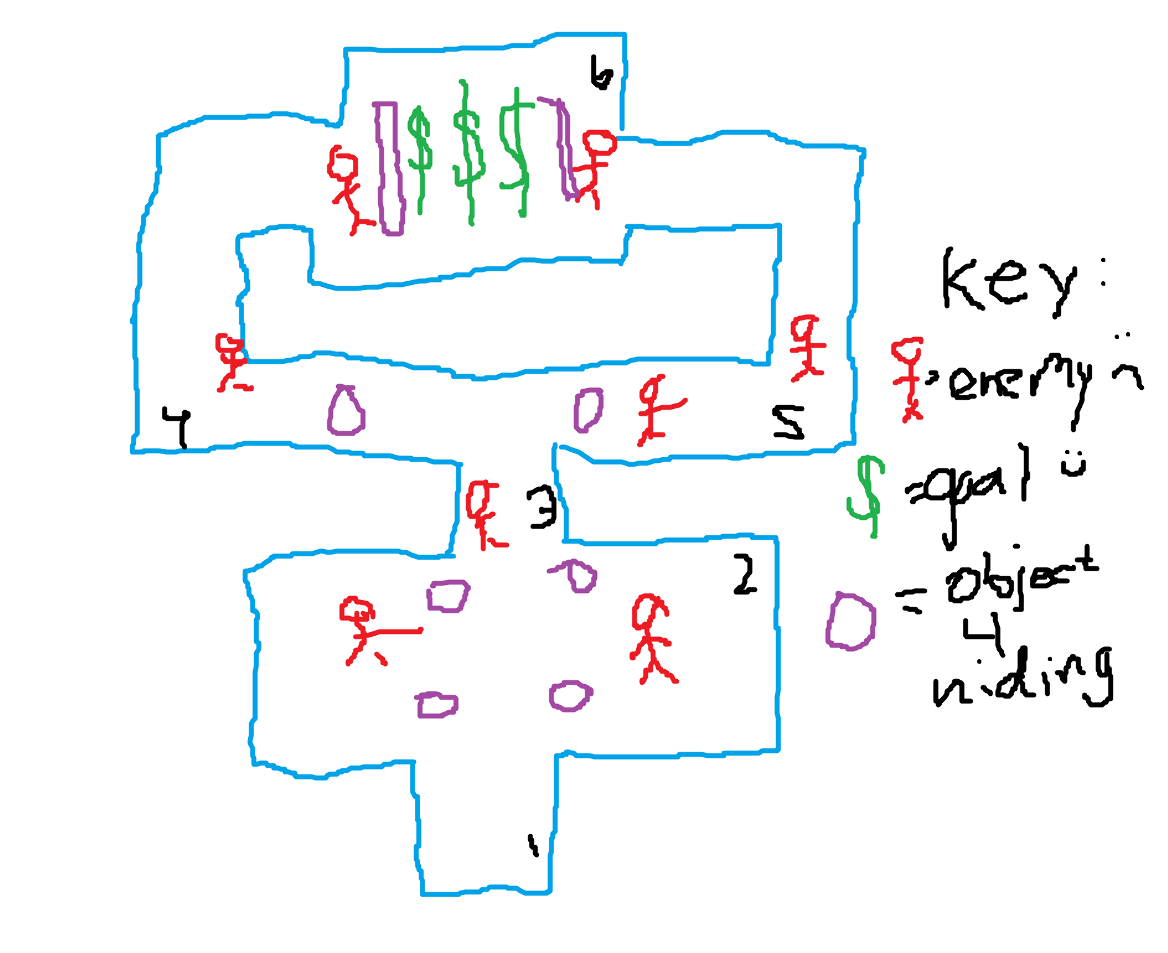

**After you steal the money and exit the building**

OLD MAN (hero): Stop, thief!

PLAYER: Who the hell are you?

OLD MAN I'm with the supaheroes, sonny! Drop the money and you won't get hurt!

Choice

Fine, here you go {OLD MAN: You did a good thing today, kid. Don't ruin your life with evil. You are always welcome with the supaheroes.}

LOL: {OLD MAN: Don't laugh at an old man! You young kids! I'll show you! Go!

*Annoying Dog appears and runs up to the player*

[Text box: Annoying Dog steals your money and places dog residue in your hands.]

OLD MAN: Ha! Take that! Not so tough now, are we?}

*Old Man runs away*

**Back at headquarters**

FLYING CHICK: Great, you're back. I'm a bit surprised. I wasn't sure you'd make it, punk. Where's the money?

Choice

I don't have it {FLYING CHICK: (mad) Well, where is it? Why didn't you get it!? I knew I should've given the job to someone else.

PLAYER: It wasn't my fault! I stole it, but an old man came and took it from me!

FLYING CHICK: What? An old man… Shit, it must have been the supaheroes. This changes things. We may have another job for you yet, punk.}

Give dog residue {FLYING CHICK: What the fuck is this?

[Text box: Dog residue multiplied!]

FLYING CHICK: (mad) Agh! Make it stop! What are trying to do!? Where is the money!? Haven't you seen some before? You know, green paper things and shiny coins?? This is not it, punk!

PLAYER: An old man stole it, and gave me this.

FLYING CHICK: What? An old man… Shit, it must have been the supaheroes. This changes things. We may have another job for you yet, punk.}